Inorganic Chemistry
Heavy Metals
Transition Elements [d-block elements]

Introduction and Characteristics.
d-block elements
The elements in which the last electron enters d-orbitals of the penultimate shell are called d-block elements.The d-block elements are also defined as those elements whose two outermost shells are partially filled.
Transition elements
The d-block elements are also called transition elements because:
1. Their position in the periodic table is between the s-block and p-block elements.
2. Their properties are transitional between the highly reactive metallic elements of s-block and the elements of p-block.
General features of transition elements
1. General valence shell electronic configuration is (n-1) d¹⁻¹⁰ ns¹⁻²
2. They have high melting and boiling point because electrons in partially filled d-orbitals participate in metallic bonding. Some exceptions are Zn, Cd and Hg (liquid at room temp.). This is because of their complete d-orbitals and the d-electrons do not participate in metallic bonding]
3. They show variable valency in their compounds because electrons from both (n-1) d and ns orbitals participate in bonding due to their comparable energy.
4. The compounds of transition metals are colored due to the presence of unpaired electrons in their d-orbitals and d-d electronic transition. [Metal ions having d⁰ and d¹⁰ configuration are colorless because there is no possibility of d-d transition due to complete filling of d-orbitals.]
5. They are so good at forming complexes. Because they have small, highly charged ions and have vacant low energy orbitals to accept lone pairs of electrons donated by other groups.
6. Many transition metals and their compounds have catalytic properties. This is because:
In some cases, the transition metals with their variable valency may form unstable intermediate compounds with reactants.
In other cases, transition metals provide a suitable reaction surface on which reactants may be absorbed.
Coinage metal
Copper (Cu), Silver (Ag) and Gold are called coinage metals because of their use in making coins.
These elements belong to group IB in the periodic table.
Copper [Cu]
Common ores of copper are:
- Chalcocite or copper glance (Cu₂S)
- Cuprite or ruby copper (Cu₂O)
- Chalcopyrite or copper pyrite (CuFeS₂)
- Azurite (blue) [Cu (OH)₂.2CuCO₃]
5. Malachite (green) [CuCO₃. Cu (OH)₂]
Extraction of copper from copper pyrite [5]
Copper is mainly extracted from its sulphide ores copper pyrite (CuFeS₂). The various steps involved in extraction are described below.
- Crushing and pulverization.
The Big lumps of ore are broken to smaller pieces by the jaw crusher and then changed to a fine powder using ball mill.
- Concentration
The powdered ore is concentrated by Froth floatation method. In this method, the powdered ore is mixed with water along with pine oil in a large tank and agitated by blowing air. The ore particles come on the surface along with froth while the impurities settle down.
Fig.

- Roasting
The concentrated ore is strongly heated in the presence of air in the reverberatory furnace. Here ores are first converted into cuprous sulphide and ferrous sulphide and then oxidized to their oxides. This process also helps to remove out impurities like P, S, As, Sb etc. in the form of their volatile oxides
S + O₂ → SO₂
4As + 3O₂ → 2As₂O₃
CuFeS₂ + O₂ → Cu₂S + FeS + SO₂
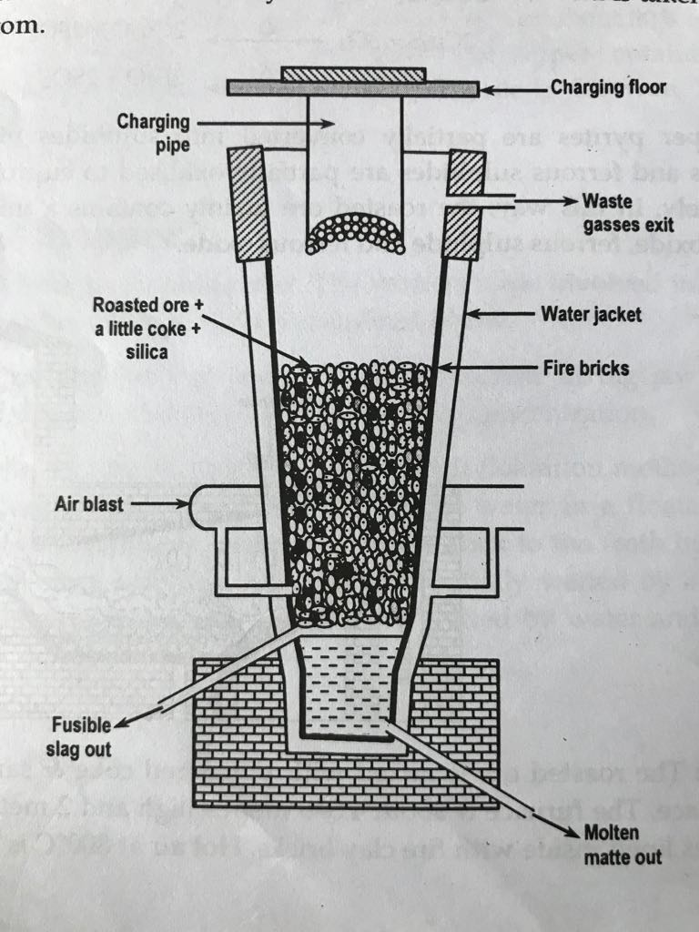
Cu₂S + O₂ → Cu₂O + SO₂
FeS + O₂ → FeO + SO₂
- Smelting/Reduction:
The roasted ore is mixed with coke (C) and sand (SiO₂) and then heated strongly in the blast furnace. The coke burns and temperature of about 1000 ^{O}C is produced. At this temperature,
a) FeS is oxidised to FeO. Thus formed FeO combines with SiO₂ to give fusible silicate slag which being lighter forms a layer on the surface and is removed through the slag hole time to time.
FeO + SiO₂ → FeSiO₃ (fusible slag)
b) Cu₂O is also converted in to copper sulphide.
Cu₂O + FeS → Cu₂S + FeO
c) Some Cu₂O are reduced by coke.
Cu₂O + C → Cu + CO
The resulting molten mass containing Cu metal, Cu₂S and FeS is called matte. Matte forms lower layer in the blast furnace and is taken out from the taping hole at the bottom.

- Bessemerization
Molten mass is mixed with SiO₂ in a Bessemer converter lined with SiO₂ and a blast of hot air is introduced. The following changes take place here.
a) Fes present in matte gets oxidised to FeO which then combines with Silica (SiO₂) lining to form slag.
FeS + O₂ → FeO + SO₂
FeO + SiO₂ → FeSiO₃ (slag)
The slag being light forms a layer on the surface which is skimmed off.
b) The Cu₂S gets oxidised to Cu₂O which is then combines with remaining Cu₂S to give free copper.
Cu₂S + O₂ → Cu₂O + SO₂
Cu₂O + Cu₂S → Cu + SO₂
The molten mass is then cooled. Then the dissolved SO₂ gas escapes out forming large blister on the metal surface. The copper metal thus formed is therefore called blister copperwhich is 98% pure.
- Purification
Purification is done by electrolysis method in which blister copper is made anode and pure copper is made cathode in an electrolytic cell containing acidified copper sulphate solution. On passing current pure copper is deposited at cathode and the impurities are collected at anode as anode mud.
Physical Properties:Self
Chemical properties of copper:
- With moist air:
When copper is exposed to moist air, a thin green film of basic copper carbonate is formed.
Cu + H₂O + CO₂ + O₂ → CuCO₃. Cu(OH)₂ [basic copper carbonate(green)]
b) With oxygen:
When copper is heated with O₂ (air) cupric oxide (black oxide) is formed which on further heating above 1100 ^{O}C changes to cuprous oxide (red oxide)
2Cu + O₂ → 2CuO (black oxide) [ below 1100 ^{O}C]
4Cu + O₂ → 2Cu₂O (red oxide) [ above 1100 ^{O}C]
c) With acids:
1) With dil. HCl and dil. H₂SO₄:Copper reacts with dil. HCl and dil. H₂SO₄ in presence of air to give salt and water.
2Cu + 4HCl + O₂ → 2CuCl₂ +2H₂O
2Cu + 2H₂SO₄ + O₂ → 2CuSO₄ + 2H₂O
2) With conc. H₂SO₄:Copper reacts with conc. H₂SO₄ to give CuSO₄ and SO
Cu + 2H₂SO₄ → CuSO₄ + H₂O + SO₂
3) With nitric acid:
Nitric acid oxidizes copper to copper nitrate and itself gets reduced.
4Cu + 10HNO₃ → 4Cu(NO₃)₂ + N₂O + 5H₂O
(dil.)
3Cu + 8HNO₃ → 3Cu(NO₃)₂ + 2NO + 4H₂O
(mod.conc.)
Cu + 4HNO₃ → Cu(NO₃)₂ + 2NO₂ + 2H₂O
(conc.)
5Cu + 12HNO₃ → 5Cu(NO₃)₂ + N₂ + 6H₂O
(hot &conc.)
d) Displacement reaction:
Copper can displace metals below it in electrochemical series from their salt solution.
Cu + 2AgNO₃ → 2Ag + Cu(NO₃)₂
3Cu + 2AuCl₃ →2 Au +3 CuCl₂
e) Reducing nature of copper:
Copper acts as reducing agent. It reduces ferric salts to ferrous salts
Cu + 2FeCl₃ → 2FeCl₂ + CuCl₂
Cu + Fe₂(SO₄)₃ → 2FeSO₄ + Cu
Comparison of chemical properties of Cu and Zn

Copper
1. With moist air:
When copper is exposed to moist air, a thin green film of basic copper carbonate is formed.
Cu + H₂O + CO₂ + O₂ → CuCO₃. Cu(OH)₂
basic copper carbonate(green)
2. With oxygen:
When copper is heated with O₂ (air) cupric oxide (black oxide) is formed which on further heating above 1100 ^{O}C changes to cuprous oxide (red oxide)
2Cu + O₂ → 2CuO (black oxide) [ below 1100 ^{O}C]
4Cu + O₂ → 2Cu₂O (red oxide) [ above 1100 ^{O}C]
3. With acids:
a.With dil. HCl and dil. H₂SO₄:
Copper reacts with dil. HCl and dil. H₂SO₄ in presence of air to give salt and water.
2Cu + 4HCl + O₂ → 2CuCl₂ +2H₂O
2Cu + 2H₂SO₄ + O₂ → 2CuSO₄ + 2H₂O
b.With conc. H₂SO₄:
Copper reacts with conc. H₂SO₄ to give CuSO₄ and SO₂
Cu + 2H₂SO₄ → CuSO₄ + H₂O + SO₂
c. With nitric acid:
Nitric acid oxidizes copper to copper nitrate and itself gets reduced.
4Cu + 10HNO₃ → 4Cu(NO₃)₂ + N₂O + 5H₂O
(dil.)
3Cu + 8HNO₃ → 3Cu(NO₃)₂ + 2NO + 4H₂O
(mod.conc.)
Cu + 4HNO₃ → Cu(NO₃)₂ + 2NO₂ + 2H₂O
(conc.)
5Cu + 12HNO₃ → 5Cu(NO₃)₂ + N₂ + 6H₂O
(hot and conc.)
4. Displacement reaction:
Copper can displace metals below it in electrochemical series from their salt solution.
Cu + 2AgNO₃ → 2Ag + Cu(NO₃)₂
3Cu + 2AuCl₃ →2 Au +3 CuCl₂
5. Reducing nature of copper:
Copper acts as reducing agent. It reduces ferric salts to ferrous salts:
Cu + 2FeCl₃ → 2FeCl₂ + CuCl₂

Zinc
1)With moist air:
When Zn is exposed to moist air, a thin film of basic zinc carbonate is formed.
4Zn + 3H₂O + CO₂ + O₂ → ZnCO₃. 3Zn (OH)₂
[basic zinc carbonate(green)
2. With oxygen:
When Zn is heated with O₂ (air) at about 500 ^{O}C, it reacts with oxygen to give ZnO which is very light and fibrous and is called philosopher wool.
2Zn + O₂ → 2ZnO

3. With acids:
a.With dil. HCl and dil. H₂SO₄:
Zn reacts with dil. HCl and dil. H₂SO₄ to give hydrogen gas.
Zn + 2HCl → ZnCl₂ +H₂
Zn + H₂SO₄ → ZnSO₄ + H₂
b.With conc. H₂SO₄:
Zn reacts with conc. H₂SO₄ to give ZnSO₄ and SO₂
Zn + 2H₂SO₄ → ZnSO₄ + H₂O + SO₂
c. With nitric acid:
Nitric acid oxidises Zn to zinc nitrate and itself gets reduced.
Zn + 10HNO₃ → 4Zn (NO₃)₂ + N₂O + 5H₂O
(dil.)
Zn + 8HNO₃ → 3Zn (NO₃)₂ + 2NO + 4H₂O
(mod.conc.)
Zn + 4HNO₃ → Zn (NO₃)₂ + 2NO₂ + 2H₂O
(conc.)
Zn + HNO₃ → Zn (NO₃)₂ + NH₄NO₃ + 6H₂O
(very dil.)
4. Displacement reaction:
Zinc can displace metals below it in electrochemical series from their salt solution.
Zn + 2AgNO₃ → 2Ag + Zn (NO₃)₂
Zn + CuSO₄ → Cu + ZnSO₄
5. Action with alkali:
Zn reacts with alkali to give zincate salt and hydrogen gas.
Zn + 2NaOH → Na₂ZnO₂ + H₂

Comparison between CuSO₄ and ZnSO₄

CuSO₄ [Blue vitriol]
Copper sulphate crystals (CuSO₄.5H₂O) are commonly known as ‘blue vitriol’ or ‘Nilotutho’.
Preparation:
When copper scraps are treated with hot and dil. Sulphuric acid in presence air copper sulphate is formed which on crystallization gives blue vitriol.
2Cu +2H₂SO₄ + O₂ → 2CuSO₄ + 2H₂O
CuSO₄ Solution $\underset{→}{Crystallization, heat}$ CuSO₄.5H₂O
(blue vitriol)
Properties:
1. It is a blue crystalline solid readily soluble in water.
2. Action of heat:
When blue vitriol is heated to 100^{O}C, it becomes monohydrate, at 250^{O}C it becomes anhydrous on further heating strongly to about 750 ^{O}C it decomposes to give black oxide of copper.
CuSO₄.5H₂O $\underset{→}{100 Oc}$CuSO₄.H₂O $\underset{→}{250 Oc}$ CuSO₄ $\underset{→}{750 Oc}$ CuO +
blue vitriol monohydrate anhydrous black oxide
SO₂ + O₂
3. With alkali: Copper sulphate reacts with caustic soda or caustic potash to give bluish white ppt. of cupric hydroxide.
CuSO₄ + NaOH → Cu (OH)₂ ↓ + Na₂SO₄
Bluish white ppt.
4. Action with ammonia:
When ammonia gas is passed through the copper sulphate solution, at first bluish white ppt. of cupric hydroxide is formed. On further passing excess ammonia a deep blue solution of tetra amine copper II sulphate is formed.
CuSO₄ + 2NH4OH → Cu (OH)₂ ↓ + (NH₄)₂SO₄
Cu (OH)₂ ↓ + (NH₄)₂SO₄ + 2NH₄OH → [Cu (NH₃)₄ ]SO₄ + 4H₂O
5. potassium iodide: Action with
When copper sulphate solution is treated with potassium iodide (KI), dark brown ppt. of iodine is precipitated.
CuSO₄ + KI → K₂SO₄ + Cu₂I₂ + I₂
This reaction is used to estimate Cu⁺⁺ ion in the qualitative analysis. On adding sodium thiosulphate solution to the above product, iodine gets reduced by
ZnSO₄ [White vitriol]
Zinc sulphate heptahydrate (ZnSO₄.7H₂O) is commonly known as ‘white vitriol’.
Preparation:
When zinc or ZnO or ZnCO₃ is treated with dilute sulphuric acid, zinc sulphate is formed which on crystallization gives white vitriol.
Zn + dil.H₂SO₄ → ZnSO₄ + H₂↑
ZnO + dil.H₂SO₄ → ZnSO₄ + H₂O
ZnCO₃ + dil.H₂SO₄ → ZnSO₄ + CO₂ + H₂O
ZnSO₄ (aq.) $\underset{→}{Crystallization, heat}$ ZnSO₄.7H₂O
(white vitriol)
Properties:
1. It is a white crystalline solid highly soluble in water.
2. Action of heat:
When white vitriol is heated to 150^{O}C, it becomes monohydrate. Which on further heating to 300^{O}C becomes anhydrous. On further heating strongly at 800 ^{O}C decomposes to give Zinc oxide.
ZnSO₄.7H₂O $\underset{→}{150 Oc}$ZnSO₄.H₂O $\underset{→}{300 Oc}$ ZnSO₄ $\underset{→}{800 Oc}$ ZnO +
White vitriol monohydrate anhydrous
SO₂ +O₂

3. With alkali (NaOH): ZnSO₄ reacts with NaOH to give white ppt. of zinc hydroxide which dissolves in excess NaOH to sodium zincate salt.
ZnSO₄ + NaOH → Zn (OH)₂ ↓ + Na₂SO₄₊
Zn (OH)₂ + 2NaOH → Na₂ZnO₂ + 2H₂O
4. Action with barium sulphide:
When ZnSO₄ is treated with barium sulphide, double salt lithopone is obtained, which is used as white pigment.
ZnSO₄ + BaS → Zns.BaSO₄(lithopone)
5. Formation of double salt:
White vitriol solution on crystallization with alkali metal sulphate gives double salts.
ZnSO₄ + K₂SO₄ + 6H₂O → K₂SO₄.ZnSO₄.6H₂O (double salt)
Uses of Zinc sulphate
- It is used as an eye lotion.
- It is used as electrolyte during galvanization.
- It is used for the preparation of lithopone which is a white pigment.

thiosulphate and only a white ppt. of Cu₂I₂ will be observed.
Na₂S₂O₃ + I₂ → NaI + Na₂S₄O₆
Uses of Copper sulphate
- It is used as germicide in agriculture.
- It is used as an antiseptic.
- It is used as a laboratory reagent.
- It is used in electroplating and electro refining of copper.

Galvanization:
It is the process of coating a thin layer of zinc over the surface of iron by the process of electrolysis.
Galvanization prevents the iron from rusting.
Comparative study of red oxide (Cu₂O) and black oxide (CuO) of copper

Cuprous oxide (Cu₂O)/Red oxide
Preparation:
1. When copper sulphate solution is treated with dilute sodium hydroxide, bluish white ppt. of cupric hydroxide is formed which on heating decomposes to give the black oxide of copper. Reduction of black oxide using reducing agent like glucose, formaldehyde etc. red oxide is formed.
CuSO₄ + 2NaOH → Cu (OH)₂ + Na₂SO₄
Cu (OH)₂ → CuO + H₂O
2CuO + C₆H₁₂O₆ → Cu₂O + C₅H₁₁O₅COOH (gulconic acid)
2. When copper is heated in air above 1100 ^{O}C red oxide is formed.
4Cu + O₂ → 2Cu₂O (red oxide) [ above 1100 ^{O}C]
Properties
1. It is a reddish-brown powder insoluble in water.
2. Action of heat: When red oxide is heated strongly in air, it turns to black oxide. 2Cu₂O + O₂ → 4CuO (black oxide)
3. Action of hydrogen: When red oxide is heated with hydrogen, it is reduced to metallic copper.
Cu₂O + H₂ → 2Cu + H₂O
4. With acids:
With conc. HCl: it reacts with conc. HCl to give cuprous chloride.
Cu₂O + Conc.2HCl → Cu₂Cl₂ + H₂O
With conc. H₂SO₄& conc. HNO₃: It reacts with conc. H₂SO₄& conc. HNO₃ to give corresponding cupric salts due to oxidation of cuprous oxide.
Cu₂O + Conc.H₂SO₄ → CuSO₄ + H₂O + Cu
Cu₂O + Conc.2HNO₃ → Cu (NO₃)₂ + H₂O + Cu
Cupric oxide (CuO)/Black oxide
Preparation:
1. When copper sulphate solution is treated with dilute sodium hydroxide, bluish white ppt. of cupric hydroxide is formed which on heating decomposes to give the black oxide of copper.
CuSO₄ + 2NaOH → Cu (OH)₂ + Na₂SO₄
Cu (OH)₂ → CuO + H₂O
2. When copper is heated in air below 1100 ^{O}C black oxide is formed.
2Cu + O₂ → 2CuO (black oxide) [ below 1100 ^{O}C]
Properties
1. It is a black amorphous powder insoluble in water.
2. Action of heat: When black oxide is heated strongly (above 1000^{O}C), it decomposes partially to give red oxide. 4CuO → 2Cu₂ O + O₂
3. Action of hydrogen/ CO: When black oxide is heated with hydrogen, carbon monoxide etc., it is reduced to metallic copper.
CuO + H₂ → Cu + H₂O
CuO + CO → Cu + CO₂
4. With acids: Being basic oxide CuO reacts with acids to give corresponding cupric salts
CuO + 2HCl → CuCl₂ + H₂O
CuO + H₂SO₄ → CuSO₄ + H₂O
Uses of black oxide: It is used to provide blue color to glass, to estimate carbon and hydrogen present in organic compounds and to remove Sulphur from petroleum products

Uses of red oxide: It is used as an anti-rust paint and
in manufacture of red colored glass and enamels.

Chemistry of Zinc oxide/ Zinc white/Philosopher wool (ZnO)
Preparation
1. When Zinc is strongly heated in excess of air Zinc white is formed.
2Zn + O₂ → 2ZnO
2. When carbonates, nitrates or hydroxide of zinc are heated strongly, zinc oxide is formed.
ZnCO₃ → ZnO + CO₂
2Zn (NO₃)₂ → 2ZnO + 4NO₂ + O₂
Zn (OH)₂ → ZnO + H₂O
Properties
1. It is a light, white fibrous powder insoluble in water. It turns yellow when heated.
2. Action with acids: it reacts with acids to give corresponding salt and water.
ZnO + 2HCl → ZnCl₂ + H₂O
ZnO + H₂SO₄ → ZnSO₄ + H₂O
3. Action with alkali (amphoteric nature of ZnO): it reacts with caustic alkali giving zincate salts.
ZnO + NaOH → Na₂ZnO₂ + H₂O
4. Action with cobalt nitrate: When ZnO is heated with cobalt nitrate [Co (NO₃)₂], a green substance cobalt zincate is formed called Rinman’s green.
2Co (NO₃)₂$\underset{→}{Heat}$ 2CoO + 4NO₂ + O₂
ZnO + CoO$\underset{→}{Heat}$ CoZnO₂(Rinman’s green)
Rinman’s green is used as a green pigment.
This reaction is during the qualitative analysis of basic radicals.
Uses of Zinc oxide
1. It is used as white paint under the name of zinc white or Chinese white.
2. It is used in filling the cavities of teeth.
3. It is used as a medicine.
4. It is used to prepare Rinman’s green which is used as a green pigment.

Zinc [Zn]
Common ores of zinc are:
- Zinc blende (ZnS)
- Calamine (ZnCO₃)
Extraction of zinc from Zinc blende [5]
Zinc is mainly extracted from its sulphide ores Zinc blende (ZnS). The various steps involved in extraction are described below.
- Crushing and pulverization.
The Big lumps of ore are broken to smaller pieces by the jaw crusher and then changed to a fine powder using ball mill.
- Concentration
The powdered ore is concentrated by Froth floatation method. In this method, the powdered ore is mixed with water along with pine oil in a large tank and agitated by blowing air. The ore particles come on the surface along with froth while the impurities are settled down.
- Roasting
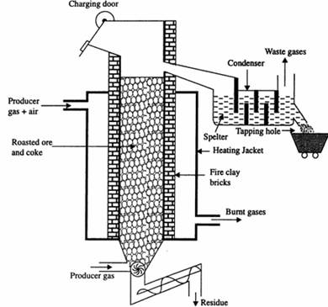
The concentrated ore is strongly heated in the presence of air in the reverberatory furnace. Here ores are converted into oxides. Some of the ores may get converted into zinc sulphate, which later decomposes to give ZnO. This process also helps to remove out impurities like P, S, As, Sb etc. in the form of volatile oxides.
2ZnS + 3O₂ → 2ZnO + 2SO₂
ZnS + O₂ → ZnSO₄
2ZnSO₄ → 2ZnO + SO₂ + 2O₂
S + O₂ → SO₂
4As + 3O₂ → 2As₂O₃
- Reduction
The roasted ore is mixed with coke (C) in the ratio of 2:1 in a vertical retort. Then the retort is heated strongly to about 1400^{O}C by burning a mixture of producer gas (CO + N₂) and air. At this temperature the oxides get reduced to metallic zinc which gets converted into its vapour form.
ZnO + C → Zn + CO
The zinc vapour and CO gas are swept away by the current of producer gas passed into the retort from the bottom. The vapour of Zn is then condensed by the water condenser. Zinc thus obtained is called spelter zinc.

- Purification
Purification is done by electrolysis method in which Spelter zinc is made anode and pure zinc is made cathode in an electrolytic cell containing acidified zinc sulphate solution. On passing current pure zn is deposited at cathode and the impurities are collected at anode as anode mud.
Physical properties of Zinc: Self

